**My Plate**

Draw a circle around the foods that are in the **Grain Group**.

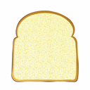 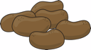  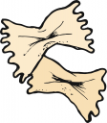 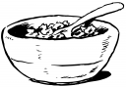 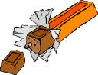

Slice of bread Baked potato Popcorn Pasta (bowtie) Cereal Candy Bar

Draw a rectanglearound the foods that are in the **Vegetable Group**.

 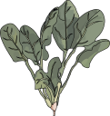  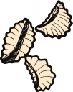  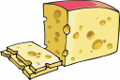

Carrots Spinach Grapes Pasta (shells) Broccoli Swiss cheese

Draw a square around the foods that are in the **Fruit Group**.

     

Corn Orange juice Apple Banana Strawberries Muffin

Draw a triangle around the foods that are in the **Dairy Group**.

   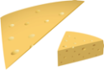  

1% Milk Yogurt Egg Cheese Cookies Orange juice

Draw an oval around the foods that are in the **Protein Group**.

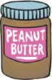  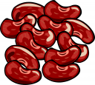   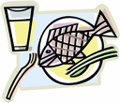

Peanut Butter Egg Beans Chicken Pork chop Fish

Please answer the following questions in complete sentences.

1. What are the basic food groups?

2. Why is the food plate icon important? Make sure you answer is detailed and complete.